Public Services

Summer project

The public services play an important role in our lives. Without them we would not have hospitals, schools, the Government, military services and many more.

Over the summer, complete the following tasks and bring your project with you ready for your first lesson.

Project title: 'The most valuable public service is .............'

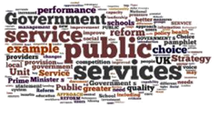

Task 1

Introduce the service that you believe is the most valuable to all citizens. It can be any public service you like. What is the purpose of the service? What are the main duties it carries out?

Task 2

Using evidence that you have researched from at least 3 different sources, explain why you believe that the service you have chosen is the most valuable to all citizens.

