A Level Bridging Work
Psychology

Please complete the following 3 tasks:
Task 1: Different Approaches: Create a summary of the following topics,
- Origins of Psychology- Who was Wilhelm Wundt- what is he know for? What is meant by introspection?
- The Behavioural Approach- Define classical and operant conditioning. Define social learning theory.
- The Cognitive Approach- Define a Schema in cognitive psychology. What is cognitive neuroscience?
- The Biological Approach- What are genotypes and phenotypes? What are neurotransmitters? What are hormones?
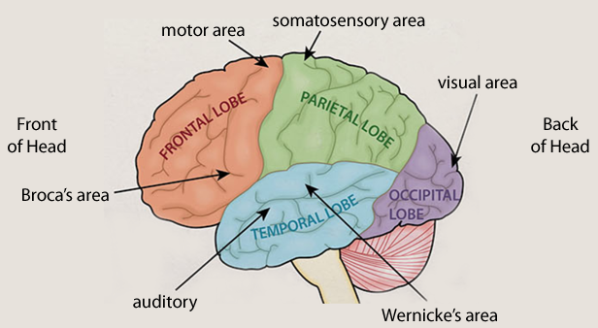
Task 2: The Human Brain Create an illustrated poster of the brain with labels that describe the location and functions of these parts of the brain:
• Auditory area
• Broca’s area
• Motor Area
• Somatosensory Area
• Visual Area
• Wernicke’s area
Task 3: Shocking Studies Create an illustrated summary of one or more of these studies in Psychology. What did the researchers do and what did we learn from them?
Shock Studies (Milgram, 1961 and more)
A Class Divided (Elliott, 1968)
Split Brain Study (Sperry, 1968)
On Being Sane in Insane Places (Rosenhan, 1973)
You can also research using books, including the textbook we will be using next year - AQA Psychology for A Level Year 1. To access the online copy, go to https://www.illuminate.digital, and click on the relevant book and use username: SWELLS Password: STUDENT.

