A Level Bridging Work
Physics
The tasks below are designed to support you as you start A Level Physics.

Complete each of the tasks below and bring your work to your first lesson.
Task 1
Complete the worksheet on prefixes and significant figures (provided at the end of this document).

Task 2

The first topic you do will be Mechanics – this is all about forces and motion.
Revise Topic 5: Forces before your first physics lesson – bring your revision notes with you.
Complete the attached exam questions: Year 12 GCSE Mechanics Recap

Task 3

Research a method to determine acceleration due to free-fall at the Earth’s surface, g.

FOLDER:

Being organised is a key part to your success at A Level.

So you are ready for September please get yourself 2 folders. One a smaller ring binder; this will be your day-to-day folder that you must bring to each and every lesson and a larger A4 lever arch file; this will be for the long term storage of your notes. Please bring these folders along with your other bridging work to the first lesson.

Inside your lever arch file you will need dividers for the following topics:

Practical Skills
Mechanics
Materials
Waves
Particles
Quantum Phenomena
Electricity

Skills | Prefixes

In Physics we have to deal with quantities from the very large to the very small. A prefix is something that goes in front of a unit and acts as a multiplier. This sheet will give you practice at converting figures between prefixes.

Symbol | Name | What it means |  | How to convert
P | peta | 10¹⁵ | 1000000000000000 |  | ↓ x1000
T | tera | 10¹² | 1000000000000 | ↑ ÷ 1000 | ↓ x1000
G | giga | 10⁹ | 1000000000 | ↑ ÷ 1000 | ↓ x1000
M | mega | 10⁶ | 1000000 | ↑ ÷ 1000 | ↓ x1000
k | kilo | 10³ | 1000 | ↑ ÷ 1000 | ↓ x1000
 |  |  | 1 | ↑ ÷ 1000 | ↓ x1000
m | milli | 10⁻³ | 0.001 | ↑ ÷ 1000 | ↓ x1000
μ | micro | 10⁻⁶ | 0.000001 | ↑ ÷ 1000 | ↓ x1000
n | nano | 10⁻⁹ | 0.000000001 | ↑ ÷ 1000 | ↓ x1000
p | pico | 10⁻¹² | 0.000000000001 | ↑ ÷ 1000 | ↓ x1000
f | femto | 10⁻¹⁵ | 0.000000000000001 | ↑ ÷ 1000

Convert the figures into the prefixes required.
s | ms | μs | ns | ps
134.6
96.21
0.773

m | km | mm | Mm | Gm
12873
0.295
57.23

kg | Mg | mg | g | Gg
94.76
0.000765
823.46

A | mA | μA | nA | kA
0.000000678
3.56
0.00092

Skills | Significant Figures

For each value state how many significant figures it is stated to.

Value | Sig Figs | Value | Sig Figs | Value | Sig Figs | Value | Sig Figs
2 |  | 1066 |  | 1800.45 |  | 0.07
2.0 |  | 82.42 |  | 2.483 x 10⁴ |  | 69324.8
2.00 |  | 750000 |  | 2.483 |  | 0.0063
0.136 |  | 310 |  | 5906.4291 |  | 9.81 x 10⁴
0.34 |  | 3.10 x 10² |  | 200000 |  | 6717
54.1 |  | 3.1 x 10² |  | 12.711 |  | 0.91

Add the values below then write the answer to the appropriate number of decimal places, which is the same decimal place as the least precise value.

Value 1 | Value 2 | Value 3 | Total | Total to correct sig figs
51.4 | 1.67 | 3.23 | 56.30 | 56.3
7146 | –32.54 | 12.8
20.8 | 18.72 | 0.851
1.4693 | 10.18 | –1.062
9.07 | 0.56 | 3.14
739762 | 26017 | 2.058
8.15 | 0.002 | 106
132.303 | 4.123 | 53800
152 | 0.8 | 0.55
0.1142 | 4922388 | 132000

Multiply the values below then write the answer to the appropriate number of significant figures which is the same as
the value with the smallest number of sig figs.

Value 1 | Value 2 | Total | Total to correct sig figs
0.91 | 1.23 | 1.1193 | 1.1
8.764 | 7.63
2.6 | 31.7
937 | 40.01
0.722 | 634.23

Yr 12 GCSE Mechanics Recap
Q1.(a) Figure 1 shows the distance–time graph for a person walking to a bus stop.
Figure 1
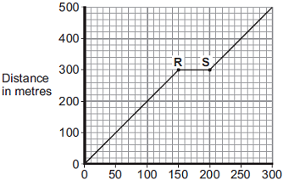
Time in seconds
(i) Which one of the following statements describes the motion of the person between points R and S on the graph?
Tick (✓) one box.
Not moving
Moving at constant speed
Moving with increasing speed

(1)
(ii) Another person, walking at constant speed, travels the same distance to the bus stop in 200 seconds.
Complete Figure 2 to show a distance–time graph for this person.
Figure 2
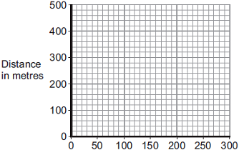
Time in seconds
(1)

(b) A bus accelerates away from the bus stop at 2.5 m/s².
The total mass of the bus and passengers is 14 000 kg.
Calculate the resultant force needed to accelerate the bus and passengers.

........................................................................................................................
........................................................................................................................
........................................................................................................................
Resultant force = ........................................ N
(2)
(Total 4 marks)

Q2.(a) Figure 1 shows the horizontal forces acting on a moving bicycle and cyclist.
Figure 1
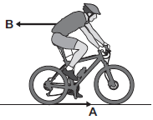
(i) What causes force A?
Draw a ring around the correct answer.
friction gravity weight
(1)

(ii) What causes force B?
...............................................................................................................
(1)

(iii) In this question you will be assessed on using good English, organising information clearly and using specialist terms where appropriate.
Figure 2 shows how the velocity of the cyclist changes during the first part of a journey along a straight and level road. During this part of the journey the force applied by the cyclist to the bicycle pedals is constant.
Figure 2
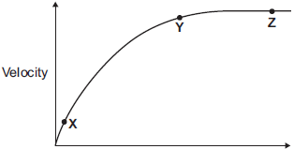
Time
Describe how and explain, in terms of the forces A and B, why the velocity of the cyclist changes:
• between the points X and Y
• and between the points Y and Z, marked on the graph in Figure 2.
...............................................................................................................
...............................................................................................................
...............................................................................................................
...............................................................................................................
...............................................................................................................
...............................................................................................................
...............................................................................................................
...............................................................................................................
...............................................................................................................
...............................................................................................................
...............................................................................................................
...............................................................................................................
...............................................................................................................
...............................................................................................................
...............................................................................................................
...............................................................................................................
...............................................................................................................
...............................................................................................................
(6)

(b) (i) The cyclist used the brakes to slow down and stop the bicycle.
A constant braking force of 140 N stopped the bicycle in a distance of 24 m.
Calculate the work done by the braking force to stop the bicycle. Give the unit.
...............................................................................................................
...............................................................................................................
...............................................................................................................
Work done = ............................................................
(3)

(ii) Complete the following sentences.
When the brakes are used, the bicycle slows down. The kinetic energy of the
bicycle ............................................................ .
At the same time, the ............................................................ of the brakes increases.
(2)
(Total 13 marks)

Q3.The figure below shows a skateboarder jumping forwards off his skateboard.
The skateboard is stationary at the moment the skateboarder jumps.
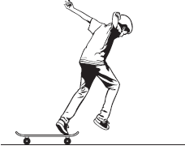
(a) The skateboard moves backwards as the skateboarder jumps forwards.
Explain, using the idea of momentum, why the skateboard moves backwards.
........................................................................................................................
........................................................................................................................
........................................................................................................................
........................................................................................................................
........................................................................................................................
........................................................................................................................
........................................................................................................................
(3)

(b) The mass of the skateboard is 1.8 kg and the mass of the skateboarder is 42 kg.
Calculate the velocity at which the skateboard moves backwards if the skateboarder jumps forwards at a velocity of 0.3 m / s.
........................................................................................................................
........................................................................................................................
........................................................................................................................
........................................................................................................................
........................................................................................................................
Velocity of skateboard = ........................................ m / s
(3)
(Total 6 marks)
Q4.The diagram shows the passenger train on part of a rollercoaster ride.
(a) Which arrow shows the direction of the resultant force acting on the passenger train?
Put a tick ( ) in the box next to your choice.
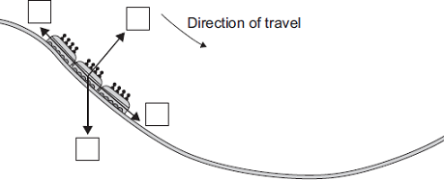
(1)

(b) For part of the ride, the maximum gravitational field strength acting on the passengers seems 3 times bigger than normal.
Normal gravitational field strength = 10 N/kg
(i) Calculate the maximum gravitational field strength that seems to act on the passengers during the ride.
...............................................................................................................
...............................................................................................................
Maximum gravitational field strength = .............................. N/kg
(1)
(ii) One of the passengers has a mass of 75 kg.
Calculate the maximum weight this passenger seems to have during the ride.
...............................................................................................................
...............................................................................................................
Maximum weight = .............................. N
(2)
(Total 4 marks)

Q5.(a) Some students have designed and built an electric-powered go-kart. After testing, the students decided to make changes to the design of their go-kart.
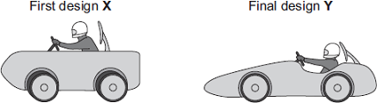
The go-kart always had the same mass and used the same motor.
The change in shape from the first design (X) to the final design (Y) will affect the top speed of the go-kart.
Explain why.
........................................................................................................................
........................................................................................................................
........................................................................................................................
........................................................................................................................
........................................................................................................................
........................................................................................................................
(3)

(b) The final design go-kart, Y, is entered into a race.
The graph shows how the velocity of the go-kart changes during the first 40 seconds of the race.
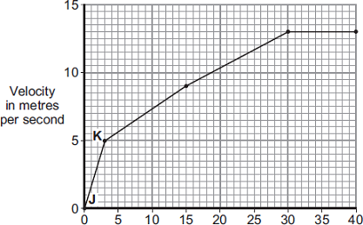
Time in seconds
(i) Use the graph to calculate the acceleration of the go-kart between points J and K.
Give your answer to two significant figures.
...............................................................................................................
...............................................................................................................
...............................................................................................................
Acceleration = ........................................ m/s²
(2)

(ii) Use the graph to calculate the distance the go-kart travels between points J and K.
...............................................................................................................
...............................................................................................................
...............................................................................................................
Distance = ........................................ m
(2)

(iii) What causes most of the resistive forces acting on the go-kart?
...............................................................................................................
(1)
(Total 8 marks)

