Photography summer project 2018

Your theme - culture

* ***This will be an independent project to be completed during the summer, following the theme of CULTURE. You may respond to this theme however you choose, below are some things for you consider -***
* ***Identify different aspects of ‘culture’ in a square mile of your location over the summer. This excludes any holiday etc.***
* ***Define what the term ‘culture’ might mean to you and the area in which you find yourself***
* ***Composition***
* ***Lighting***
* ***How you are going to make it ‘creative’ and different to reflect your culture.***
* ***How can you show your culture, and what is it you are trying to depict?***
* ***You will need to conduct research to support your mini project, this could include –***
* ***A mind map of ideas***
* ***Artist research***
* ***A MINIMUM of 2 different photoshoots***
* ***Contact sheets of each shoot, with annotations of images, e.g, are they successful? If so, why? If not, why not?***
* ***A final outcome in response to your culture***

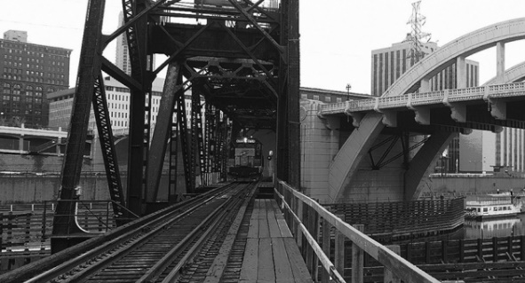

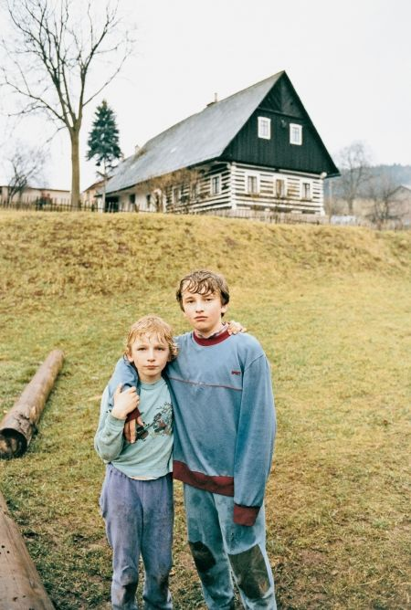

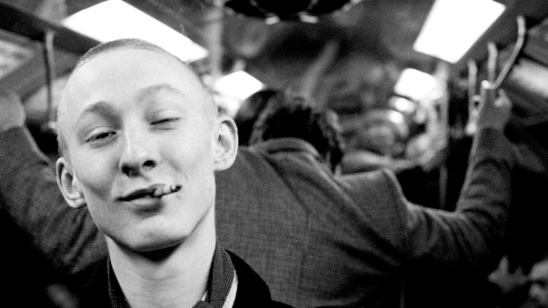

This is to be brought with you on your first lesson and group presentations will be held.