Entrepreneur research project
Over recent years the media has given the general public an insight into the lives of a number of famous entrepreneurs through the use of reality televisions programs such as ‘The Apprentice’ and ‘Dragons Den’ shown below.
These television series often glorifies the entrepreneur and doesn’t give a true insight into difficulties they face on the road to success. Even Lord Alan Sugar has taken fall-backs during his road to success. Life as an entrepreneur can be very fulfilling however can be extremely risky at times especially within the current economic climate the UK is in.
Task 1
We are aware some of you may not have completed a qualification in business at KS4 level so to give you a better understanding of the topic you are required to:
- Write a detailed definition to what an entrepreneur actually is
- Identify the characteristics needed to be a successful entrepreneur
- Explain how these characteristics can assist the person to become an entrepreneur
(Must be completed in your own words)
Task 2
The UK public are familiar with famous entrepreneurs. For this task you are a journalist for the ‘Financial Times’ and have been assigned to write an article on an entrepreneur of your choice. Some examples famous entrepreneurs are shown: (choose your own that interests you)
The article must resemble a newspaper layout and be at least 2 sides of A4 type. It must include:
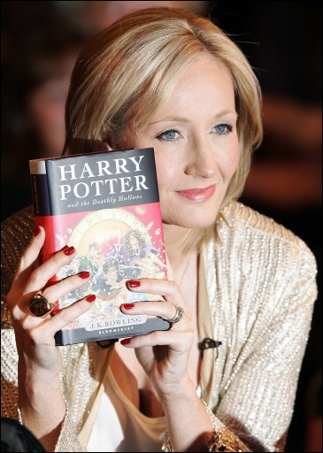
- Biography
- Why did they become an entrepreneur?
- Characteristics that made them an entrepreneur
- Companies they own, what products/services do they provide?
- Where the idea for the business came from?
- What makes their business different from competitors?
- What difficulties they have faced along the way?

