A Level Bridging Work
Biology
The tasks below are designed to support you as you start A Level Biology.

Complete each of the tasks below and bring your work to your first lesson.
Task 1

Write an essay (between 600-700 words) about what you feel are the most important discoveries in biology.

Task 2

During your first few lessons you will complete a project on enzymes and this project will be written up as a report.

To start this report, research enzymes and write an introduction. This should include:

- An overview of the role and action of enzymes

- How enzymes work in terms of the lock and key theory and the induced fit theory. Challenge – how are these theories different and which one is more accepted and why?

- What factors can change the rate of enzyme controlled reactions and try to describe the effect each factor has. This could include, but not be limited to, temperature, pH and substrate concentration.

- A challenge for you will be to not only describe the effect, but to explain the impact the factor has on the enzyme / the overall reaction. You will want to discuss ideas like bonding and tertiary structure.

- Information about trypsin, the specific enzyme you will use, and casein, the substrate, which is a protein found in milk.

A good report will include sub-headings, diagrams and references. Your reference list should include the author’s name, year of publication, publisher and title. If you are unsure, this link will help: http://www.bbc.co.uk/schools/gcsebitesize/dida/managing_projects/copyrightrev4.shtml

If possible, complete this task using a word processor so you can easily modify and improve your work during later stages of the report.

Task 3

To follow up on this research complete the past paper questions on enzymes. There are questions of differing demand, however, please attempt them all.

Folder
Being organised is a key part to your success at A Level.

So you are ready for September please get yourself 2 folders. One a smaller ring binder, this will be your day-to-day folder that you must bring to each and every lesson, and a larger A4 lever arch file, this will be for the long term storage of your notes. Please bring these folders along with your other bridging work to the first lesson.

Inside your lever arch file you will need dividers for the following topics:

Year 12 Content

Module 2.1:

2.1.1 - Cell Biology
2.1.2 - Biological Molecules
2.1.3 - Nucleotides & Nucleic Acids
2.1.4 - Biological Membranes
2.1.5 - Enzymes
2.1.6 - Cell Division

Module 3.1:

3.1.1 - Exchange surfaces
3.1.2 - Animal Transport
3.1.4 - Plant Transport

Module 4.1:

4.1.1 - Communicable disease
4.2.1 - Biodiversity
4.2.2 - Classification and Evolution

Year 13 Content

Module 5.1:

5.1.1 - Communication and Homeostasis
5.1.2 - Excretion
5.1.3 - Neuronal Communication
5.1.4 - Hormonal Communication
5.1.5 - Plant and Animal Responses
5.2.1 - Photosynthesis
5.2.2 - Respiration

Module 6.1:

6.1.1 - Cellular Control
6.1.2 - Patterns of Inheritance
6.1.3 - Manipulating Genomes
6.2.1 - Cloning and Biotechnology
6.3.1 - Ecosystems
6.3.2 - Populations and Sustainability

Tests

GCSE
Q1. (easier)
(a) Enzymes are used in body cells.
(i) What is an enzyme?
Draw a ring around the correct answer.

an antibody | a catalyst | a hormone
(1)
(ii) All enzymes are made of the same type of substance.
What is this substance?
Draw a ring around the correct answer.

carbohydrate | fat | protein
(1)
(iii) Where is the enzyme amylase produced in the human body?
Draw a ring around the correct answer.

liver | salivary glands | stomach
(1)
(b) Enzymes are sometimes used in industry.
Draw one line from each enzyme to the correct industrial use of that enzyme.

Enzyme |  | Industrial use
 |  | Changes starch into sugars
Carbohydrase
Removes grease stains from
clothes
Isomerase
Pre-digests proteins in some
baby foods
Protease
Changes glucose syrup into
fructose syrup
(3)
(Total 6 marks)
Q2. (harder)

Starch is broken down into sugar by amylase. Amylase is produced in the salivary glands.
(a) Name two other organs in the digestive system which produce amylase.
____________________________ and ____________________________
(2)
(b) A colorimeter measures colour intensity by measuring the percentage of light that passes through a solution.
Graph 1 shows the percentage of light passing through sugar solutions of different concentrations to which a test reagent has been added.
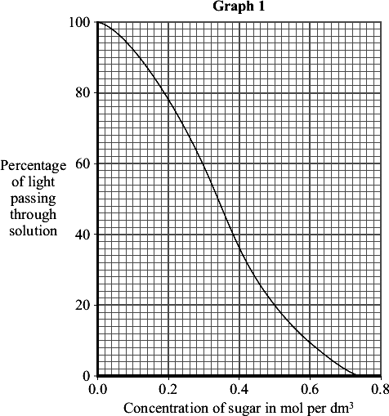
Students used a colorimeter to compare the starch-digesting ability of amylase enzymes obtained from two organs, P and Q.
• The students collected 5 cm³ samples of amylase from P and Q and placed them into a water-bath at 40 °C.
• Two test tubes containing 10 cm³ samples of starch solution were also placed into the water-bath.
• All the tubes were left in the water-bath for 10 minutes.
• Each amylase sample was added to one of the tubes containing the starch solution.
• The test tubes were placed back into the water-bath.
• Every minute, a few drops were taken from each tube, the test reagent was added and the percentage of light passing through this solution was measured in the colorimeter.

The tubes containing amylase samples and starch solution were left in the water-bath for ten minutes before the amylase was added to the starch.
Explain why.
___________________________________________________________________
___________________________________________________________________
___________________________________________________________________
___________________________________________________________________
(2)
(c) Graph 2 shows how the readings from the colorimeter changed over the next 20 minutes.
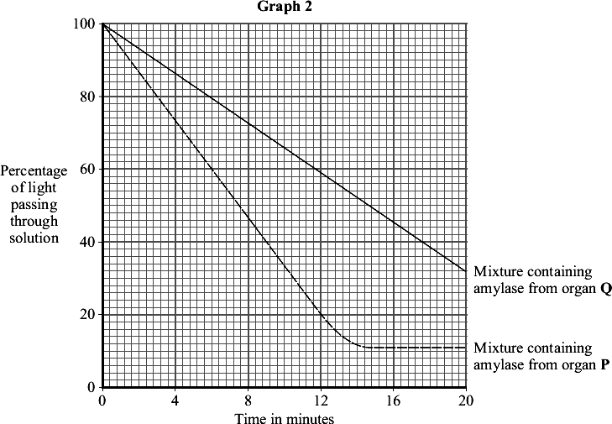
(i) Use Graph 1 and Graph 2 to determine the concentration of sugar in the mixture from organ Q after 20 minutes.
______________________________________________________________
Answer _____________ mol per dm³
(1)

(ii) Use your answer to (c)(i) to calculate the rate at which sugar was produced in the mixture containing amylase from organ Q.
Show clearly how you work out your answer.
______________________________________________________________
______________________________________________________________
______________________________________________________________
Answer _______________________ mol per dm³ per minute
(2)
(iii) Suggest why the amount of light passing through the mixture from organ P did not change after 16 minutes.
______________________________________________________________
______________________________________________________________
______________________________________________________________
(1)
(iv) One of the students suggested that they could have completed their experiment more quickly if the temperature of the water-bath had been set at 80 °C.
This would not have been the case.
Explain why.
______________________________________________________________
______________________________________________________________
______________________________________________________________
______________________________________________________________
______________________________________________________________
(2)
(Total 10 marks)

A Level - up to grade C

A Level - up to grade A

