A Level Bridging Work 2020-2021
A-Level English Language and Literature
The tasks in this pack are designed to support you as you prepare to start
A-Level English Language and Literature.
These tasks have been developed to build on your GCSE knowledge and help with the transition into sixth form, using your time wisely over the coming months to ensure you maintain a level of education that will be needed to be successful in your subject when you enroll into the sixth form in August/September.
PiXL English have produced a fantastic booklet with a wide range of activities exploring Language and Literature. To make the most of this resource, you should work through the booklet and complete the following activities, and as many more challenges as you like:
Section 1: Complete Activity 1, and one or more other activities from this section
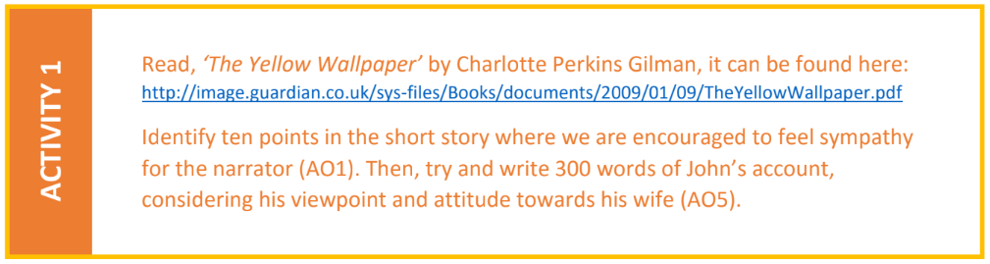
Section 2: Complete Activity 5, and one or more other activities from this section
Bring your response to class in September
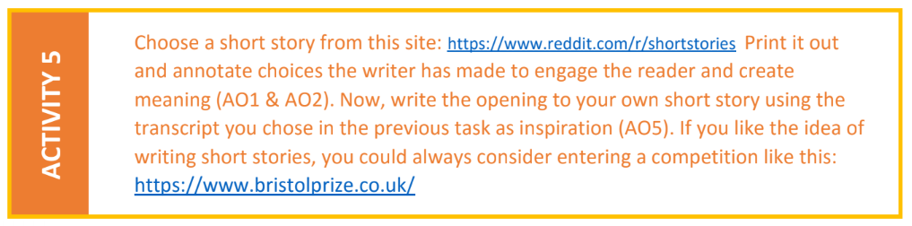
Section 3: Complete all the activities to build your technical knowledge and skills
Section 4: Try the Handmaid’s Tale challenge, based on the opening scenes of the novel
Section 5: Optional extension activities and challenges to expand your knowledge and skills

