A Level Bridging Work 2020-2021
CTEC Level 3 Business Studies
The tasks below are designed to support you as you prepare to start
Cambridge Technical Level 3 Extended Certificate in Business Studies.
These tasks have been developed to build on your GCSE knowledge and help with the transition into sixth form, using your time wisely over the coming months to ensure you maintain a level of education that will be needed to be successful in your subject when you enroll into the sixth form in August/September.
Dear future Year 12 students,
We have designed this task to prepare you for your Year 12 studies in Business, but also as a document that you will KEEP at the front of your folders as a glossary of the key terms that you need to know. It will be very useful to you!
Activity 1: Research definitions of Business Studies key terms. The key terms are sorted by sections of the specification. This is the activity you should bring with you to class in Sept.
**IMPORTANT** Do not copy and paste from the internet. This is a task to aid your understanding of Business. Read though the definitions you discover online and show that you really understand the concepts by writing your own definitions in your own words.
Activity 2: Complete the Challenge tasks for each section – doing this will enhance your knowledge and benefit you throughout Year 12.
Activity 3: Complete the National Business Research Challenge. The content of the project will help you develop your knowledge and understanding of Business in context.
Please feel free to contact Miss Armes or Miss Webb if you have any questions. We would be very pleased to hear from you. LAS@sbllearning.org.uk and EWB@sbllearning.org.uk

Useful resources and websites to help you:
First is a fantastic website, made specifically for this course! It covers all of the main points of the specification and will be in constant use during your Unit 1 and 2 studies:
https://www.businessed.co.uk/index.php/home/theory/cambtec/cambtec-l3-theory
Other GCSE business websites will be helpful to you when gathering key terms:
- https://www.bbc.co.uk/bitesize/subjects/zpsvr82
- https://revisionworld.com/gcse-revision

Course textbook: if you know you are definitely going to take CTEC Business, then we recommend that you purchase this. The textbook is available at full price from the publisher, Hodder Education. Other retailers have discounted and second-hand versions.
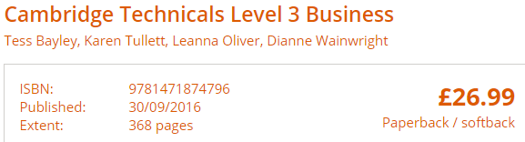
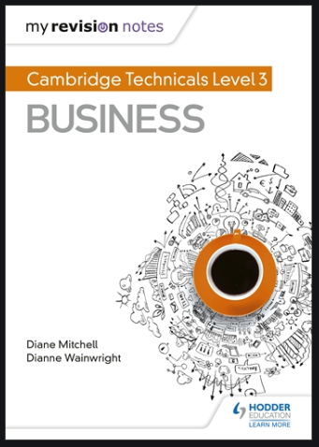
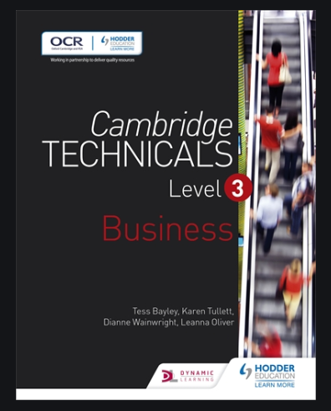
Course revision guide:
CTEC Business Studies Key Terms Glossary
Unit 1: Types of business activity
Business activities
Retail customers
Business customers
L01 – Different types of businesses and their aims and objectives
Sole Trader
Partnership
Private limited company (Ltd)
Public limited company (PLC)
Public sector
Charity, not for profit or third sector
Community interest company (CIC)
Unlimited liability
Limited liability
Aims
Objectives
Economies of Scale
Diseconomies of scale
Recession
LO2 – Understanding how functional areas of business work together to support the activities of business.
Unique selling point (USP)
Functional area
Statement of financial position
Income statement
Cash flow forecasting
Pricing strategy
Disciplinary procedure
Grievance procedure
LO3 – Understand the effect that different organisational structures have on how businesses operate.
Flat structure
Hierarchical / tall structure
Centralised structure
Decentralised structure
Matrix structure
Span of control
Accountability
L04 – Be able to use financial information to check the financial health of a business.
Assets
Revenue
Cash flow
Net cash flow
Cash flow forecast
Cash flow statement
Income statement
Profit
Gross profit
Net profit
Loss
Cost
Cost of sales
Opportunity cost
Break even
Margin of safety
Depreciation
Insolvent
L05 - Who the main stakeholders are and their objectives?
Stakeholder
Internal stakeholder
External stakeholder
L06 - Understand the external influences and constraints on businesses, and how businesses respond.
External influences
Social factors
Technological factors
Economic factors
Retained profit
Environmental factors
Ethical factors
L07 - Understand why businesses plan
Business plan
L08 - Be able to assess the performance of businesses to inform future business activities
Business performance
Financial analysis
Key performance indicators (KPI)
SWOT analysis
Diversification
UNIT 2: WORKING IN BUSINESS
LO1 Understand protocols to be followed when working in business
Protocol
Line Manager
Embezzlement
Plagiarism
L02 Understand factors the influence the arrangement of business meetings
There are no new key terms in this section.
L03 - Be able to use business documents
Payment terms
Budget
Favourable variance
Adverse variance
Leasing
Standing order
Direct Debit
L04 Be able to prioritise business tasks
Direct report
Interim deadline
L05 Understand how to communicate effectively with stakeholders
Audience
Consumables
Press release
Unit 1 Challenges
L01 – Different types of businesses and their aims and objectives
CHALLENGE: Can you find a real life business example for each of the seven types of business ownership?
LO2 – Understanding how functional areas of business work together to support the activities of business.
CHALLENGE: Can you research the main ‘functions’ of a business and write a brief sentence outlining each one?
LO3 – Understand the effect that different organisational structures have on how businesses operate.
CHALLENGE: All forms of business structure can be represented with a diagram. Can you draw five diagrams to illustrate the five types of business structure on this list?
L04 – Be able to use financial information to check the financial health of a business.
CHALLENGE: Can you make a note of the FORMULA used to calculate – profit, revenue, net profit, and gross profit?
L05 - Who the main stakeholders are and their objectives?
CHALLENGE: Using Ocean Estate Agents as an example, can you identify examples of internal and external stakeholders?
L06 - Understand the external influences and constraints on businesses, and how businesses respond.
CHALLENGE: Using a global business you are familiar with, can you create a mind map that shows how the 7 external factors influence the business you have chosen?
L07 - Understand why businesses plan
CHALLENGE: Can you explain what might be included in a business plan?
UNIT 2 Challenges
LO1 Understand protocols to be followed when working in business
CHALLENGE: Can you think of a protocol that you have had to use and explain why?
L03 - Be able to use business documents
CHALLENGE: Can you create a ‘fictional’ budget for someone who wants to start a car washing company from home?
L05 Understand how to communicate effectively with stakeholders
CHALLENGE: Can you find an example of an official press release in the media?

