A Level Bridging Work 2020-2021
BTEC Public Services
The tasks below are designed to support you as you prepare to start BTEC Public Services.
These tasks have been developed to build on your GCSE knowledge and help with the transition into sixth form, using your time wisely over the coming months to ensure you maintain a level of education that will be needed to be successful in your subject when you enroll into the sixth form in August/September.
Activity 1: What are the Public Services?
You should familiarise yourself with the different uniformed public services that exist in the UK. Below are the links to the main services, but there are more. Can you find any more?
Create a mindmap, slideshow or other types of notes that shows the range of public services in the UK – be careful to check that all your information relates to the UK only.
- https://www.gov.uk/
- https://www.army.mod.uk/
- https://www.raf.mod.uk/
- https://www.royalnavy.mod.uk/
- https://www.police.uk/
- https://www.avonfire.gov.uk/
- https://www.swast.nhs.uk/welcome
- https://www.gov.uk/government/organisations/hm-prison-service

Activity 2: Assess the contribution of the Public Services to citizens’ lives.
The public services play a hugely important role in all our lives. Without them, we would not have hospitals, police, schools, the fire service, prison service, military and much more. We know all these services are important, but which is the most important? This is an extended written project that you should bring to your first lesson in September.
Project title: 'The most valuable public service is .............'
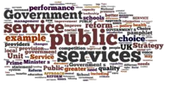
Task 1: Introduce the service that you believe is the most valuable to all citizens. It can be any public service you like. What is the purpose of the service? What are the main duties it carries out?
Task 2: Using evidence and arguments that you have researched from at least 3 different sources, explain why you believe the service you have chosen is the most valuable to all citizens, in your opinion.
Challenge: Compare your service to other services and explain why it is more valuable.
Activity 3: How is the British Government structured?
In Unit 1, you learn about the structure and functions of the Government, because the government is responsible for the public services. The UK is a constitutional monarchy, which means we have a king or queen as our Head of State but real power lies with Parliament. To prepare, research governance in the UK and create a set of notes:
- Outline the institutions that make up our government, with examples:
- Branches of government (Executive, Legislative, Judicial)
- Monarchy
- House of Lords
- House of Commons
- Outline the job roles in government, with examples:
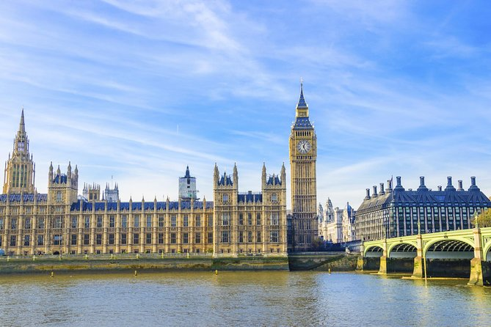
- Monarch
- Prime minister
- Cabinet
- Government ministers
- Members of parliament
- Mayors
- Local council members
Activity 4: How do we pay for the Public Services?
- Where does the money come from to pay for the police, fire service and NHS?
- How much does the national government spend on Public Services? Find graphs or charts from the past 5 years to show how the government spends our money.
- How much do local governments spend on Public Services each year? Look on your local council website to find out how much they raised and spent last year.
Challenge: Why are there problems with funding Britain’s public services, e.g. what is austerity, and what should we do about the issue of funding our services in the future?
Activity 5: Equality and Diversity in the Public Services
Create a keyword list with a definition of the words below, including an example of each:
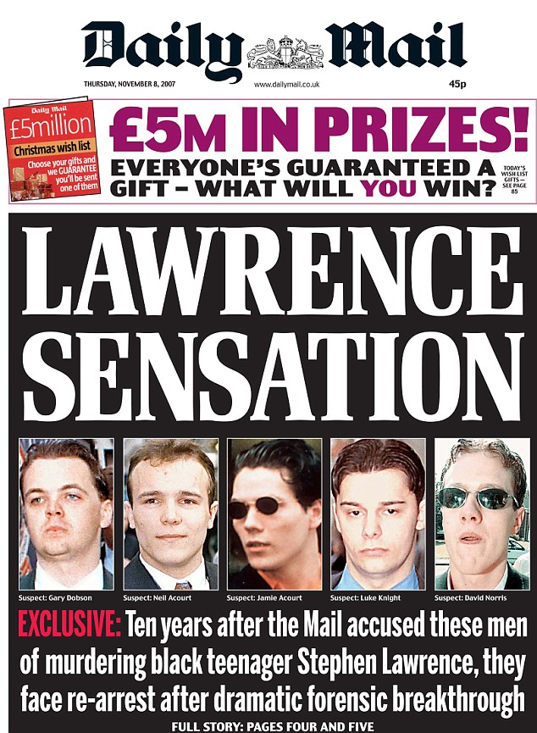
- Racism,
- Racist,
- Institutionalised racism,
- Multiculturalism,
- Ethnocentricity,
- Sexism,
- Heterosexist,
- Homophobia,
- Equal opportunity,
- Equality,
- Prejudice,
- Harassment,
- Victimisation,
- Disability,
- Direct and indirect discrimination
Challenge: Why is it so important for the Public Services to be aware of these issues? What happens when Public Services do not respect equality and diversity? (e.g. news above).

