A Level Bridging Work 2020-2021
A-Level Photography
The tasks below are designed to support you as you prepare to start A-Level Photography.
These tasks have been developed to build on your GCSE knowledge and help with the transition into sixth form, using your time wisely over the coming months to ensure you maintain a level of education that will be needed to be successful in your subject when you enroll into the Sixth Form in August/September.
Activity 1: VISUAL DIARY
Create a photo diary of your time ‘In Lockdown’.
You can include: Daily portraits, a food diary, photos that show how you feel, photos from your daily exercise, photos of what you see on TV, photos of objects you use every day.
If you have a printer you could print your images and create a photo journal with them.
Activity 2: FRAMING
Photographers sometimes use parts of their image as a technique for framing and so direct the viewer’s attention to a particular part of the picture.
Photographs by Christopher Anderson, Henri Cartier-Bresson and Alex Webb show how doorways, windows, mirrors or gaps in walls can be used to frame a subject. Irving Penn sometimes used corners to direct attention towards his subject and Laura Letinsky often uses the edges of tables to frame her still life arrangements.
Create a series of photographs that explore framing techniques. 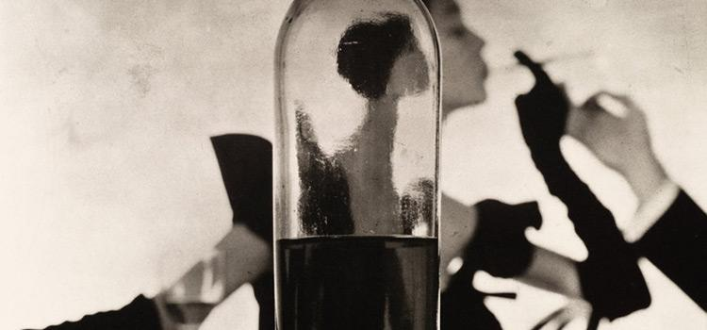 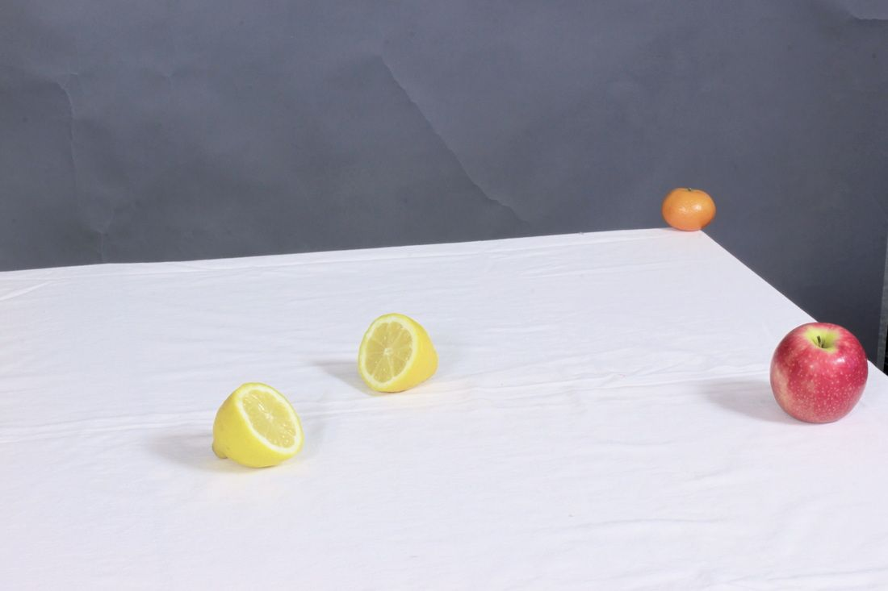 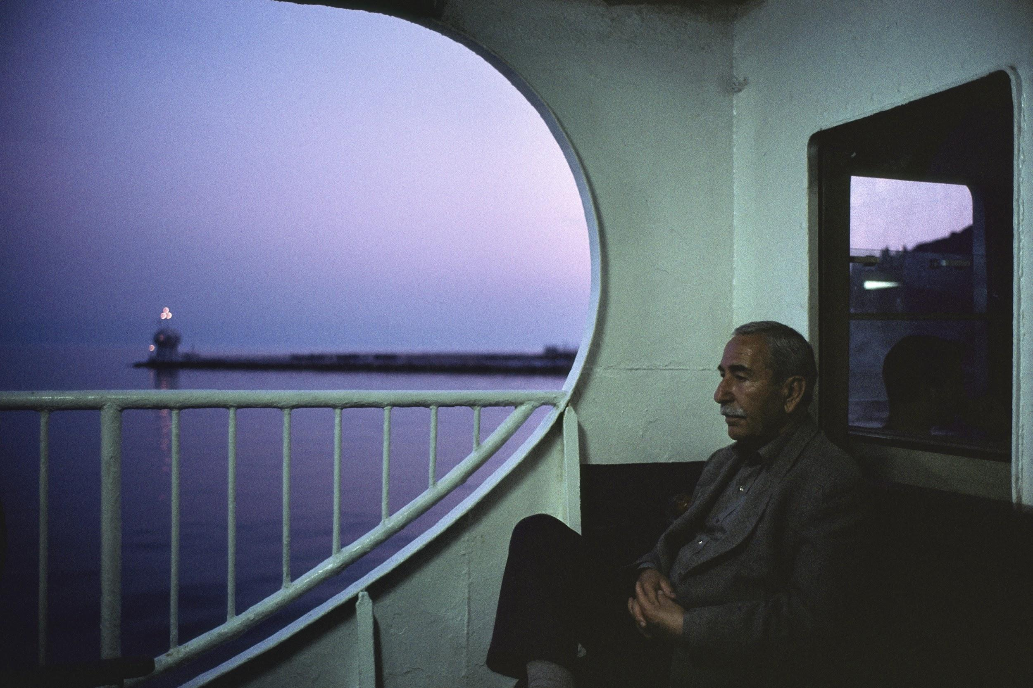
Activity 3: ANALYSING AN IMAGE
Explore contemporary photography, e.g. at the following websites:
- http://photography-now.com/
- https://www.magnumphotos.com/
- https://www.bjp-online.com/
- https://fstoppers.com/
- https://www.npg.org.uk/
Select a photograph that interests you to analyse using the critical analysis questions below:
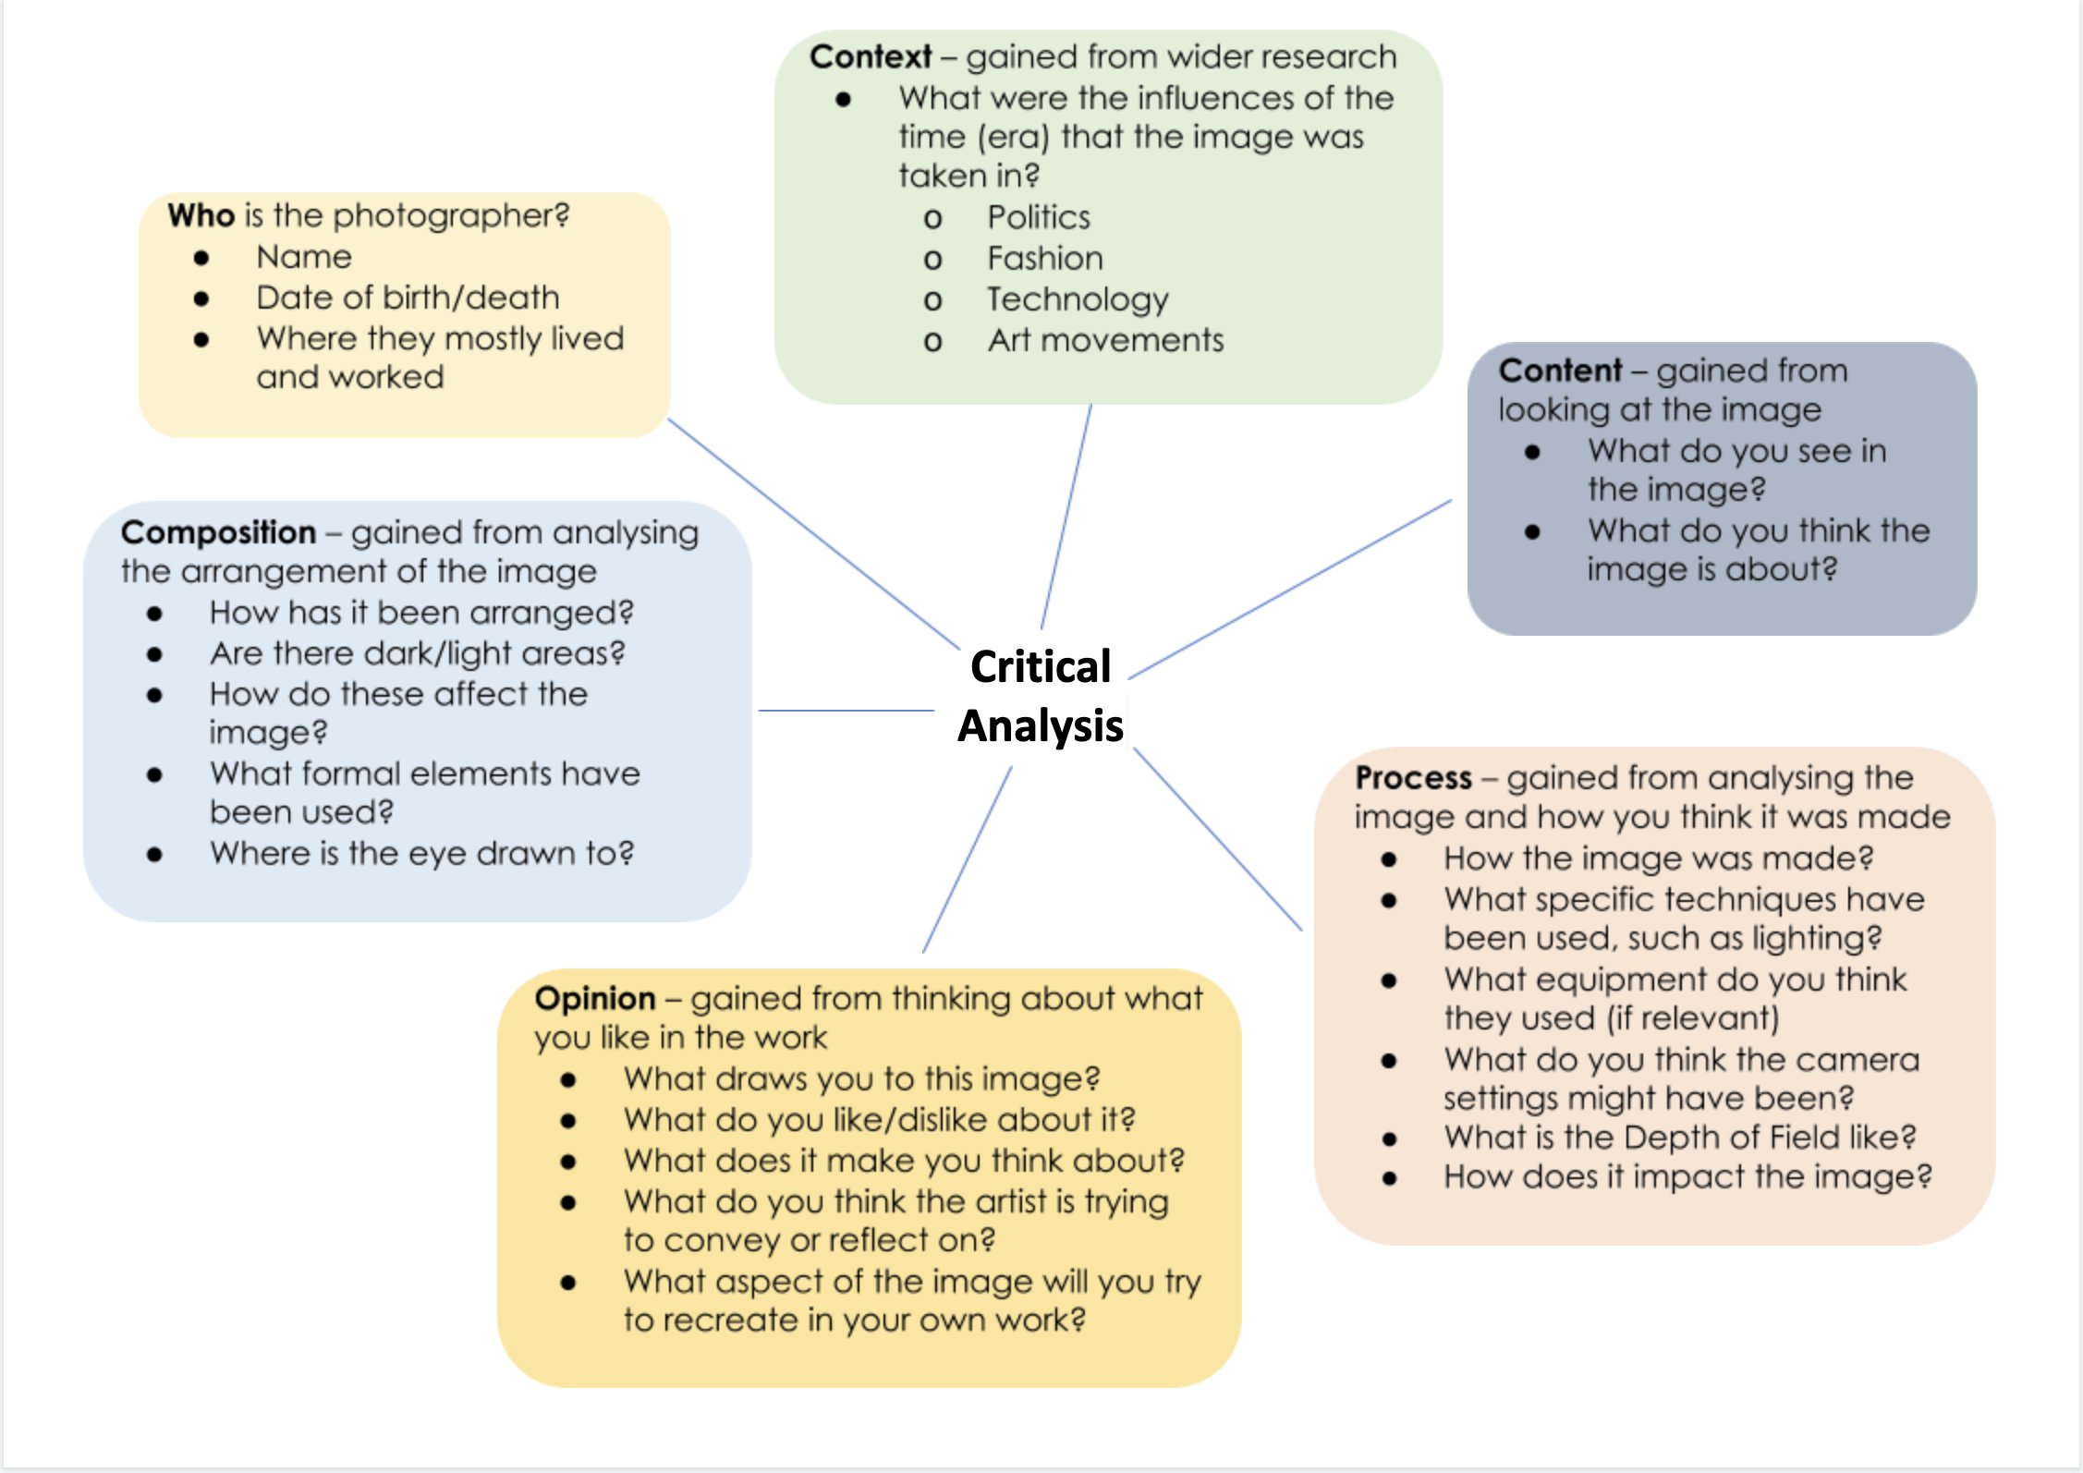
Note: Depth of Field refers to the depth of focus - blurred background= shallow depth of field, whereas a sharp background = deep depth of field.

ACTIVITY 4: Artists Response
- Select a Photographer or photo that interests and inspires you, print images of the work and present them creatively with detailed annotations describing the work and your thoughts about it.
- Create your own response to the photographer/image you have chosen. Use the image to inspire how you create yours, but it must be your own work - do not directly copy what the photographer has done. You might take an idea, technique, theme or all of these things but you will be producing your own work.
- Present all work creatively, you could buy a sketchbook, make your own, use card or board etc. Experiment and link your presentation style to your artist’s work.
BRING THIS PROJECT TO CLASS IN SEPTEMBER FOR FEEDBACK AND DISPLAY

Man Ray (1890-1976)
