A Level Bridging Work 2020-2021
Fine Art
The tasks below are designed to support you as you prepare to start A Level Fine Art.

These tasks have been developed to build on your GCSE knowledge and help with the transition into sixth form, using your time wisely over the coming months to ensure you maintain a level of education that will be needed to be successful in your subject when you enroll into the sixth form in August/September.
Your challenge for Term 6 and into the summer is to plan and produce your own creative response to the Coronavirus pandemic. Work through the following tasks and activities towards creating this piece of artwork. Your final response will then be exhibited at SBL Academy in September.

TASK 1 – RECORDING YOUR THOUGHTS AND IDEAS ABOUT COVID-19

Create a mind map exploring a wide range of ideas around this theme. How has life changed? New rules? Slogans…. Things you have done, seen, read about? Things you could draw? Personal thoughts and opinions? What do you miss? How are people in the public eye coping? What’s made you laugh/cry?

TASK 2 – EXPLORING THE WORK OF ARTISTS

Look at what other Artists have created in response to the Coronavirus pandemic. Note down ideas from their work, make drawings from their work and find out about the different techniques and materials that they have used. If you can print, create a mood-board of your favourite work with annotations explaining your thoughts and ideas. Below are some examples of what some Artists have done……….

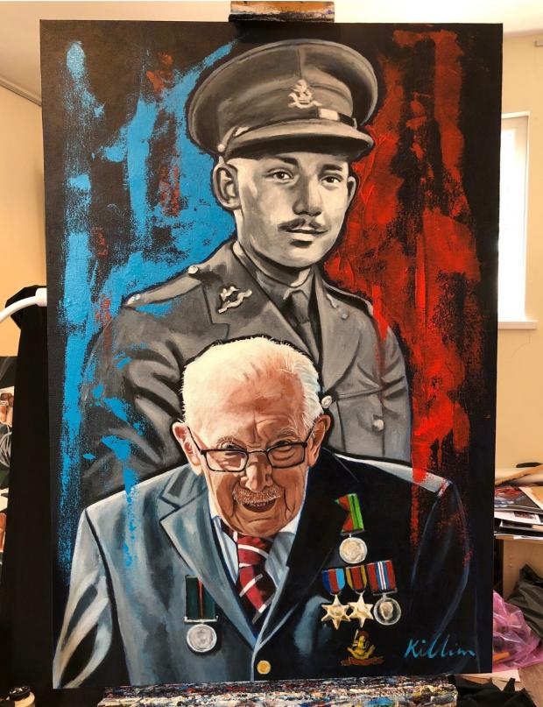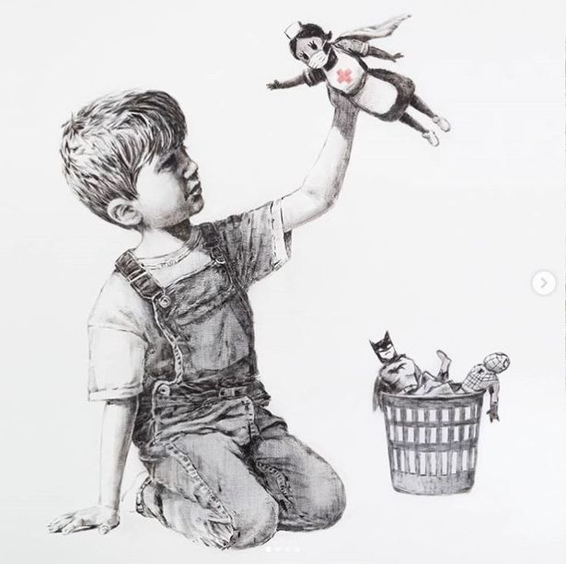

Artist Patrick Killian has created a portrait of Colonel Tom Moore, now and when he was serving in the second world war. Captain Tom has raised over £30 million for the NHS by walking laps of his garden.

Banksy recently created this drawing above of a young boy who has discarded his old super hero figures in the waste bin to play with a new hero figure!

Artist Nathan Wyburn has created a digital mosaic portrait made up of hundreds of photos of health workers on the front line.
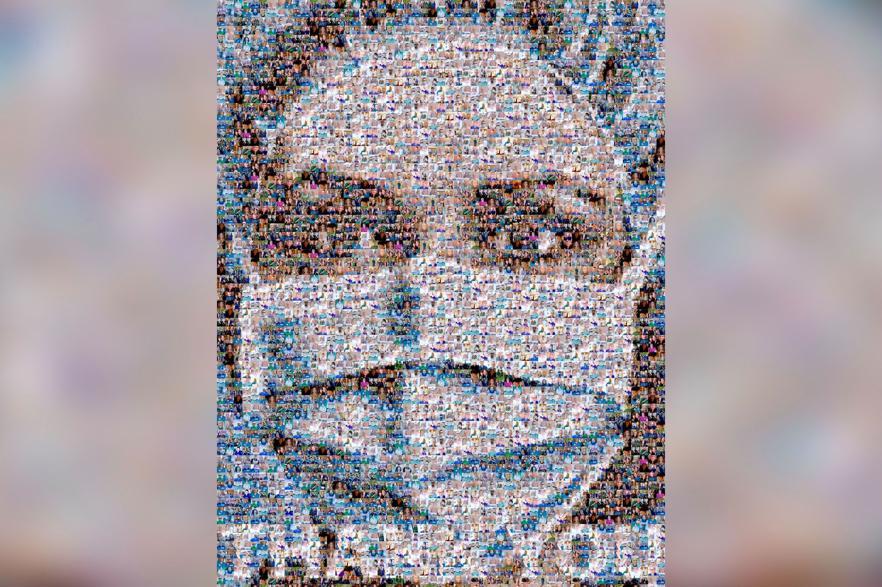

Artist Chris Shea has created Banksy inspired paintings on people’s walls:
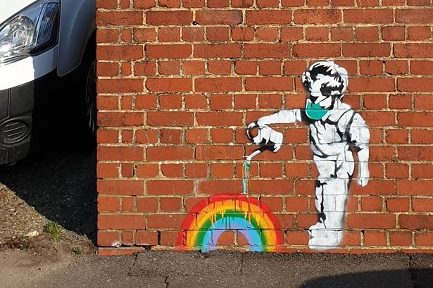

Street Art inspired by Covid-19:
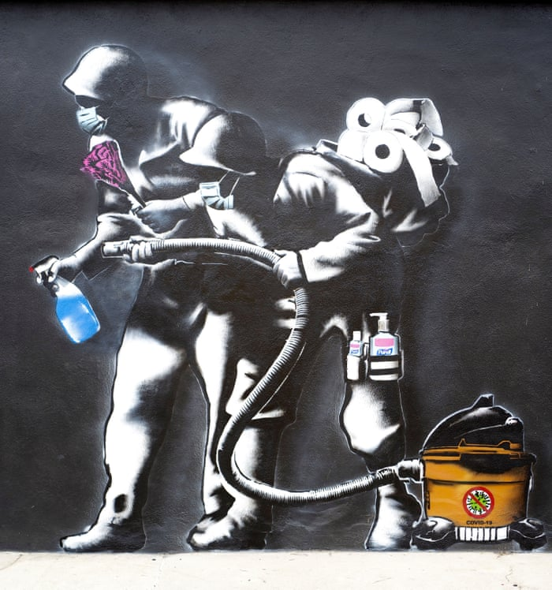
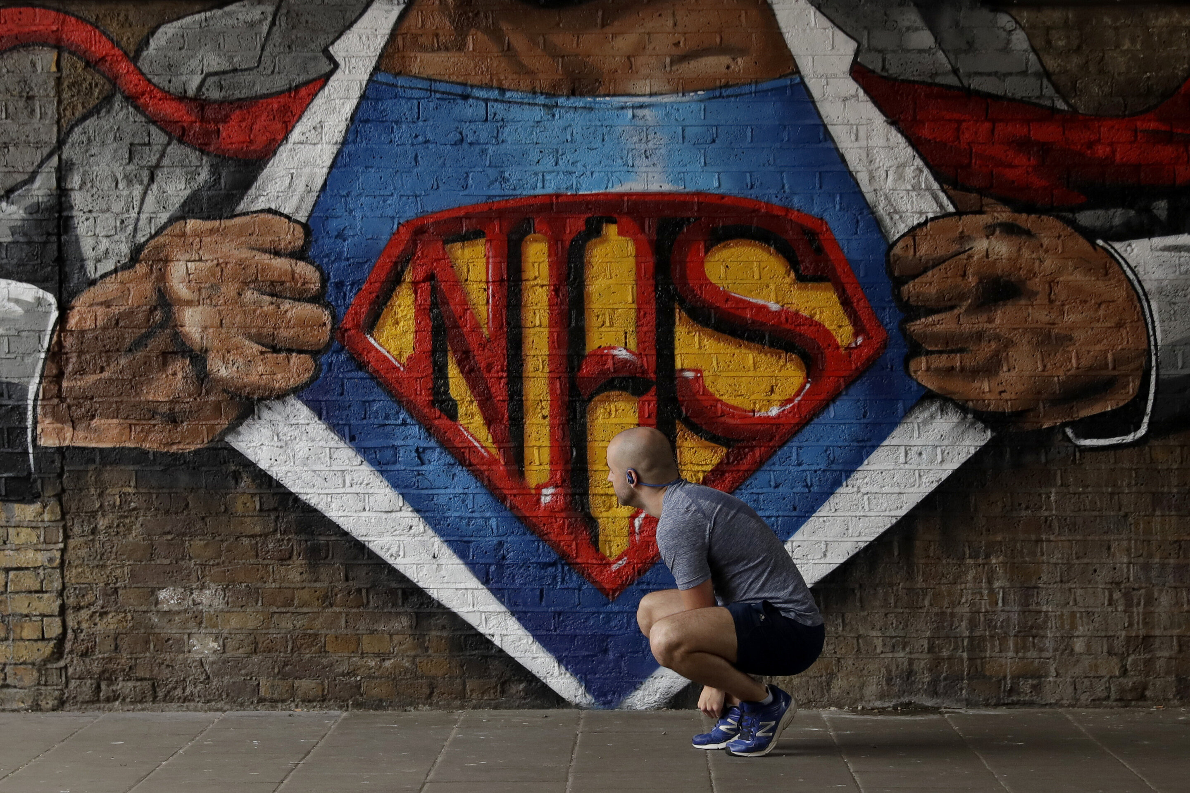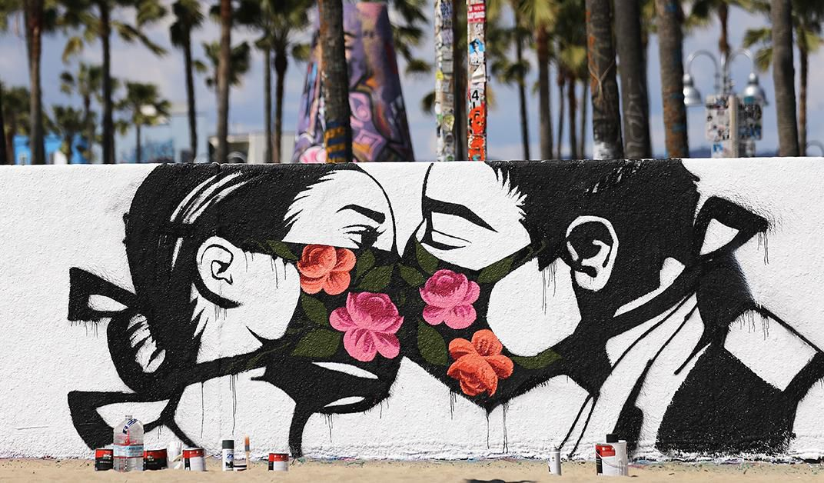

TASK 3 – DRAFTING IDEAS AND TESTING MATERIALS

Sketch out a range of composition ideas of what you want to include in your final piece of work, try different arrangements/layouts of things. Play around with size and scale. Always work from real life, internet images or your own photos, e.g. If I was going to draw clapping hands in my piece of work I would find an image like the one below to draw from. Keep drafting ideas until you find the best one, show your drafts to a family member and ask for advice. Remember you could email me your draft for feedback before you complete your final piece. JDR@sblonline.org.uk

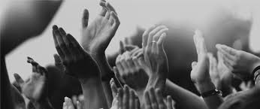

- Take ideas from the artists you have looked at and think about the message you want to show in your work.
- Then, think about what mediums you love to work in and test materials on your drafts to find the best way of creating your final piece. Colour/Black and white? Drawn, collaged, painted, mixed media, digital?
- Remember you could watch YouTube tutorials if you want reminders on how to create tone and texture with different materials.
TASK 4 – FINAL PIECE

This is the work you will submit in September. You will receive feedback, and you will also have a chance to exhibit your work at SBL Academy, where Fine Art is taught.

Create your final response on whatever surface you like, paper, card, board, wood, canvas, a wall…. (remember to get consent from the wall owner!) The work can be any size and you can use any medium…… be adventurous and enjoy!

I look forward to seeing you and your work in September, Ms Draper

